ex 1a(DES)

import javax.crypto.*;
import java.security.*;
import java.util.Base64;

public class DES {
public static void main(String[] args) {
try {
System.out.println("Message Encryption using DES Algorithm\n");
KeyGenerator keyGen = KeyGenerator.getInstance("DES");
SecretKey key = keyGen.generateKey();

Cipher cipher = Cipher.getInstance("DES/ECB/PKCS5Padding");

String text = "University College of Engineering Nagercoil";
System.out.println("Original Message: " + text);

cipher.init(Cipher.ENCRYPT_MODE, key);
byte[] encrypted = cipher.doFinal(text.getBytes());
System.out.println("Encrypted Message:" + Base64.getEncoder().encodeToString(encrypted));

cipher.init(Cipher.DECRYPT_MODE, key);
byte[] decrypted = cipher.doFinal(encrypted);
System.out.println("Decrypted Message:" + new String(decrypted));

} catch (Exception e) {
e.printStackTrace();
}
}
}

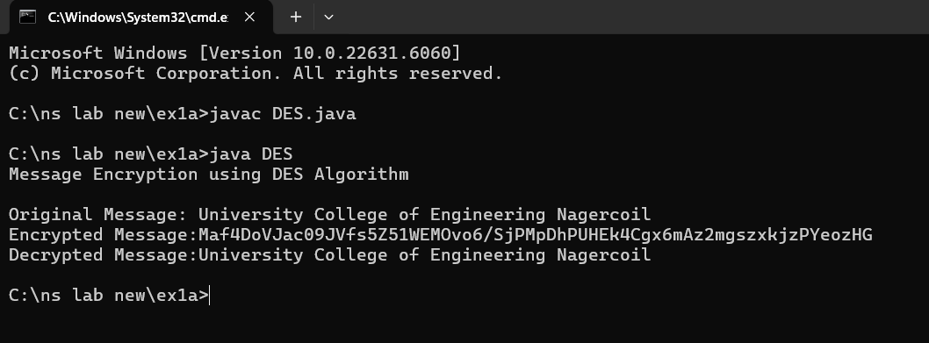

ex 1b(AES)

import javax.crypto.*;
import java.security.*;
import java.util.Base64;

public class AES {
public static void main(String[] args) {
try {
System.out.println("Message Encryption using AES Algorithm\n");
KeyGenerator keyGen = KeyGenerator.getInstance("AES");
keyGen.init(128);
SecretKey Key = keyGen.generateKey();

Cipher cipher = Cipher.getInstance("AES/ECB/PKCS5Padding");

String url = "www.annauniv.edu";
System.out.println("Original URL: " + url);

cipher.init(Cipher.ENCRYPT_MODE, Key);
byte[] encrypted = cipher.doFinal(url.getBytes());
String encryptedText = Base64.getEncoder().encodeToString(encrypted);
System.out.println("Encrypted URL: " + encryptedText);

cipher.init(Cipher.DECRYPT_MODE, Key);
byte[] decrypted = cipher.doFinal(Base64.getDecoder().decode(encryptedText));
System.out.println("Decrypted URL: " + new String(decrypted));

} catch (Exception e) {
e.printStackTrace();
}
}
}

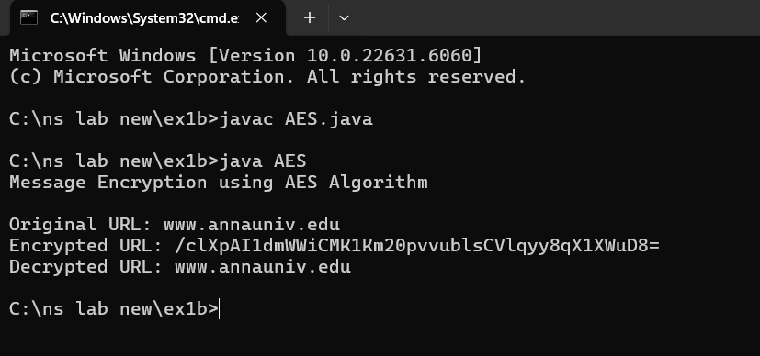

ex 2a(RSA)

<!DOCTYPE html>
<html>
<head><title>RSA Encryption</title></head>
<body>
<center>
<h1>RSA Algorithm</h1>
<h3>Implemented Using HTML & Javascript</h3><hr>
<table>
<tr><td>Enter First Prime Number:</td><td><input id="p" value="53"></td></tr>
<tr><td>Enter Second Prime Number:</td><td><input id="q" value="59"></td></tr>
<tr><td>Enter the Message (A=1,B=2,...):</td><td><input id="msg" value="89"></td></tr>
<tr><td>Public Key:</td><td><span id="n"></span></td></tr>
<tr><td>Exponent:</td><td><span id="e"></span></td></tr>
<tr><td>Private Key:</td><td><span id="d"></span></td></tr>
<tr><td>Cipher Text:</td><td><span id="ct"></span></td></tr>
<tr><td colspan="2" align="center"><button onclick="RSA()">Apply RSA</button></td></tr>
</table>
</center>
<script>
function RSA(){
let p=53,q=59,msg=89,n=p*q,t=(p-1)*(q-1),e,d,ct;
const gcd=(a,b)=>b?gcd(b,a%b):a;
for(e=2;e<t;e++)if(gcd(e,t)==1)break;
for(let i=1;i<10;i++){let x=1+i*t;if(x%e==0){d=x/e;break;}}
ct=Math.pow(msg,e)%n;
document.getElementById("n").innerText=n;
document.getElementById("e").innerText=e;
document.getElementById("d").innerText=d;
document.getElementById("ct").innerText=Math.round(ct);
}
</script>
</body>
</html>
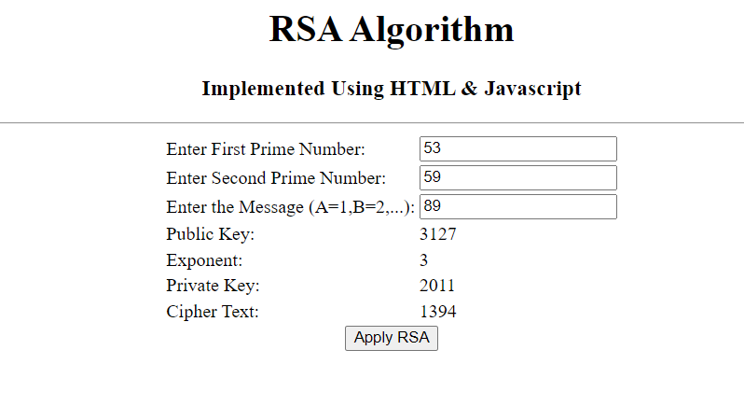

ex 2b(Diffie Hellman)

class DiffieHellman {
public static void main(String[] args) {
int p = 23, g = 5, x = 4, y = 3;
double aliceSend = Math.pow(g, x) % p;
double bobSend = Math.pow(g, y) % p;
double aliceComp = Math.pow(bobSend, x) % p;
double bobComp = Math.pow(aliceSend, y) % p;
double shared = Math.pow(g, x * y) % p;

System.out.println("Simulation of Diffie-Hellman Key Exchange Algorithm\n");
System.out.println("Alice sends: " + aliceSend);
System.out.println("Bob computes: " + bobComp);
System.out.println("Bob sends: " + bobSend);
System.out.println("Alice computes: " + aliceComp);
System.out.println("Shared Secret: " + shared);

if (aliceComp == shared && aliceComp == bobComp)
System.out.println("Success: Shared secrets match! " + shared);
else
System.out.println("Error: Shared secrets do not match!");
}
}

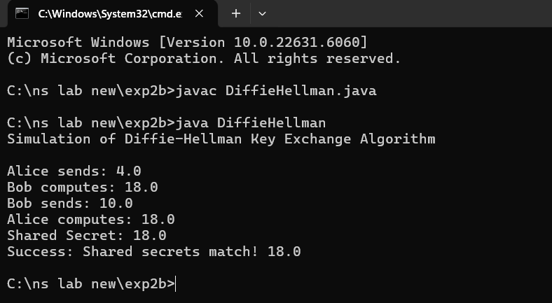

ex 3(DigitalSignature)

import java.security.*;
import java.util.*;

public class CreatingDigitalSignature {
public static void main(String[] args) throws Exception {
Scanner sc = new Scanner(System.in);
System.out.print("Enter some text: ");
String msg = sc.nextLine();

KeyPairGenerator kpg = KeyPairGenerator.getInstance("DSA");
kpg.initialize(2048);
PrivateKey priv = kpg.generateKeyPair().getPrivate();

Signature sig = Signature.getInstance("SHA256withDSA");
sig.initSign(priv);
sig.update(msg.getBytes());

String encoded = Base64.getEncoder().encodeToString(sig.sign());
System.out.println("Digital signature for given text: " + encoded);
}
}

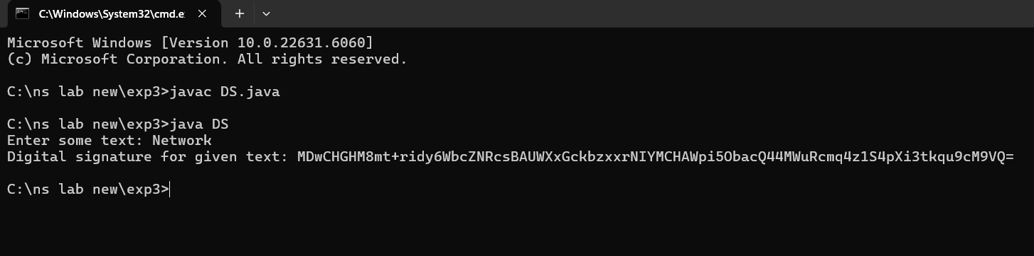

Ex5(message integrity confidentiality using ssl)

Server.java

import javax.net.ssl.*;
import java.io.*;
import java.security.KeyStore;

public class Server {
public static void main(String[] args) throws Exception {

KeyStore ks = KeyStore.getInstance("JKS");
ks.load(new FileInputStream("serverkeystore.jks"), "password123".toCharArray());

KeyManagerFactory kmf = KeyManagerFactory.getInstance(KeyManagerFactory.getDefaultAlgorithm());
kmf.init(ks, "password123".toCharArray());

SSLContext ctx = SSLContext.getInstance("TLS");
ctx.init(kmf.getKeyManagers(), null, null);

SSLServerSocket server = (SSLServerSocket) ctx.getServerSocketFactory().createServerSocket(8443);
System.out.println("Server running on port 8443");

while (true)
new Thread(() -> handle(server)).start();
}

private static void handle(SSLServerSocket server) {
try (SSLSocket s = (SSLSocket) server.accept();
BufferedReader in = new BufferedReader(new InputStreamReader(s.getInputStream()));
PrintWriter out = new PrintWriter(s.getOutputStream(), true)) {

for (String msg; (msg = in.readLine()) != null; )
out.println("Echo: " + msg);

} catch (Exception e) {
e.printStackTrace();
}
}
}

Client.java

import javax.net.ssl.*;
import java.io.*;
import java.security.KeyStore;

public class Client {
public static void main(String[] args) throws Exception {

KeyStore ts = KeyStore.getInstance("JKS");
ts.load(new FileInputStream("clienttruststore.jks"), "password123".toCharArray());

TrustManagerFactory tmf = TrustManagerFactory.getInstance(TrustManagerFactory.getDefaultAlgorithm());
tmf.init(ts);

SSLContext ctx = SSLContext.getInstance("TLS");
ctx.init(null, tmf.getTrustManagers(), null);

try (SSLSocket s = (SSLSocket) ctx.getSocketFactory().createSocket("localhost", 8443);
BufferedReader in = new BufferedReader(new InputStreamReader(s.getInputStream()));
PrintWriter out = new PrintWriter(s.getOutputStream(), true);
BufferedReader console = new BufferedReader(new InputStreamReader(System.in))) {

s.startHandshake();
System.out.println("Connected. Type messages (exit to quit):");

for (String msg; !(msg = console.readLine()).equalsIgnoreCase("exit"); ) {
out.println(msg);
System.out.println("Server: " + in.readLine());
}
}
}
}

Folder structure:

SSLChat/
├── Server.java
├── Client.java

Generate server keystore

keytool -genkeypair -alias serverkey -keyalg RSA -keysize 2048 -keystore serverkeystore.jks -validity 365 -storepass password123 -keypass password123 -dname "CN=localhost,OU=IT,O=MyCompany,L=City,S=State,C=US"

Export the server certificate

keytool -export -alias serverkey -file servercert.cer -keystore serverkeystore.jks -storepass password123

Create the client truststore and import the server certificate

keytool -import -alias servercert -file servercert.cer -keystore clienttruststore.jks -storepass password123 -noprompt

